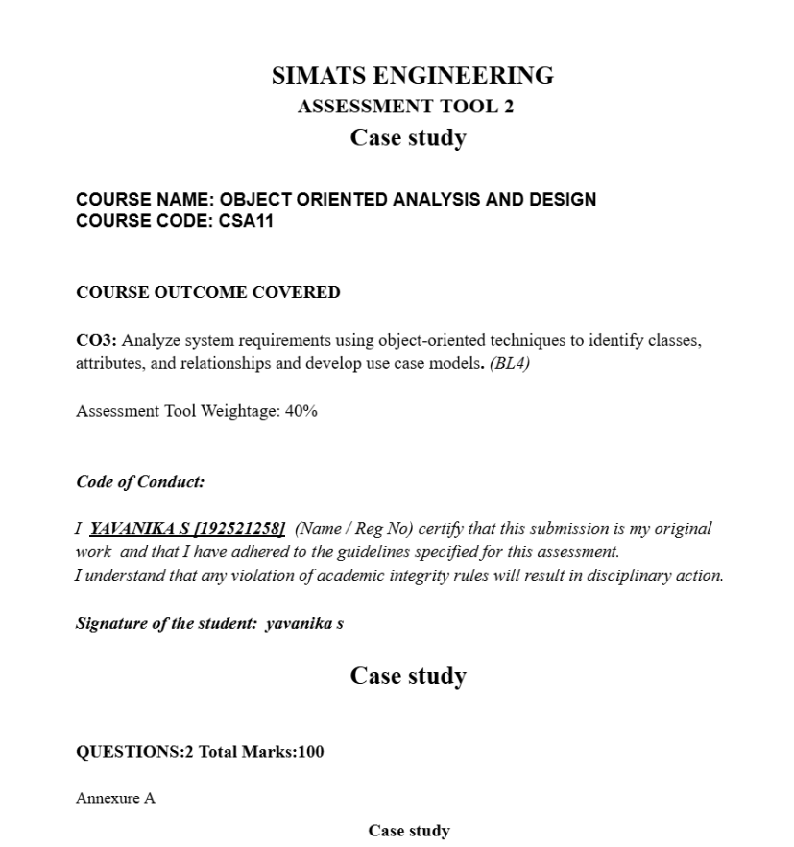

a) E-Learning Platform An educational institution wants to build an e-learning system where instructors upload courses, students enrol, take quizzes, and receive certificates. The system should support scalability and frequent updates.
Question: Discuss how modular software design can be achieved using object-oriented techniques. Evaluate different SDLC models and select the most appropriate one for this scenario with justification.
b) Smart Parking System A city introduces a smart parking system where users can check parking availability, reserve slots, and make payments through a mobile app. Sensors update real-time availability.
Question: Apply object-oriented system development principles to design this system. Identify the life cycle model best suited for handling real-time data and evolving requirements, and explain why.

A)
- Modular OOP design:

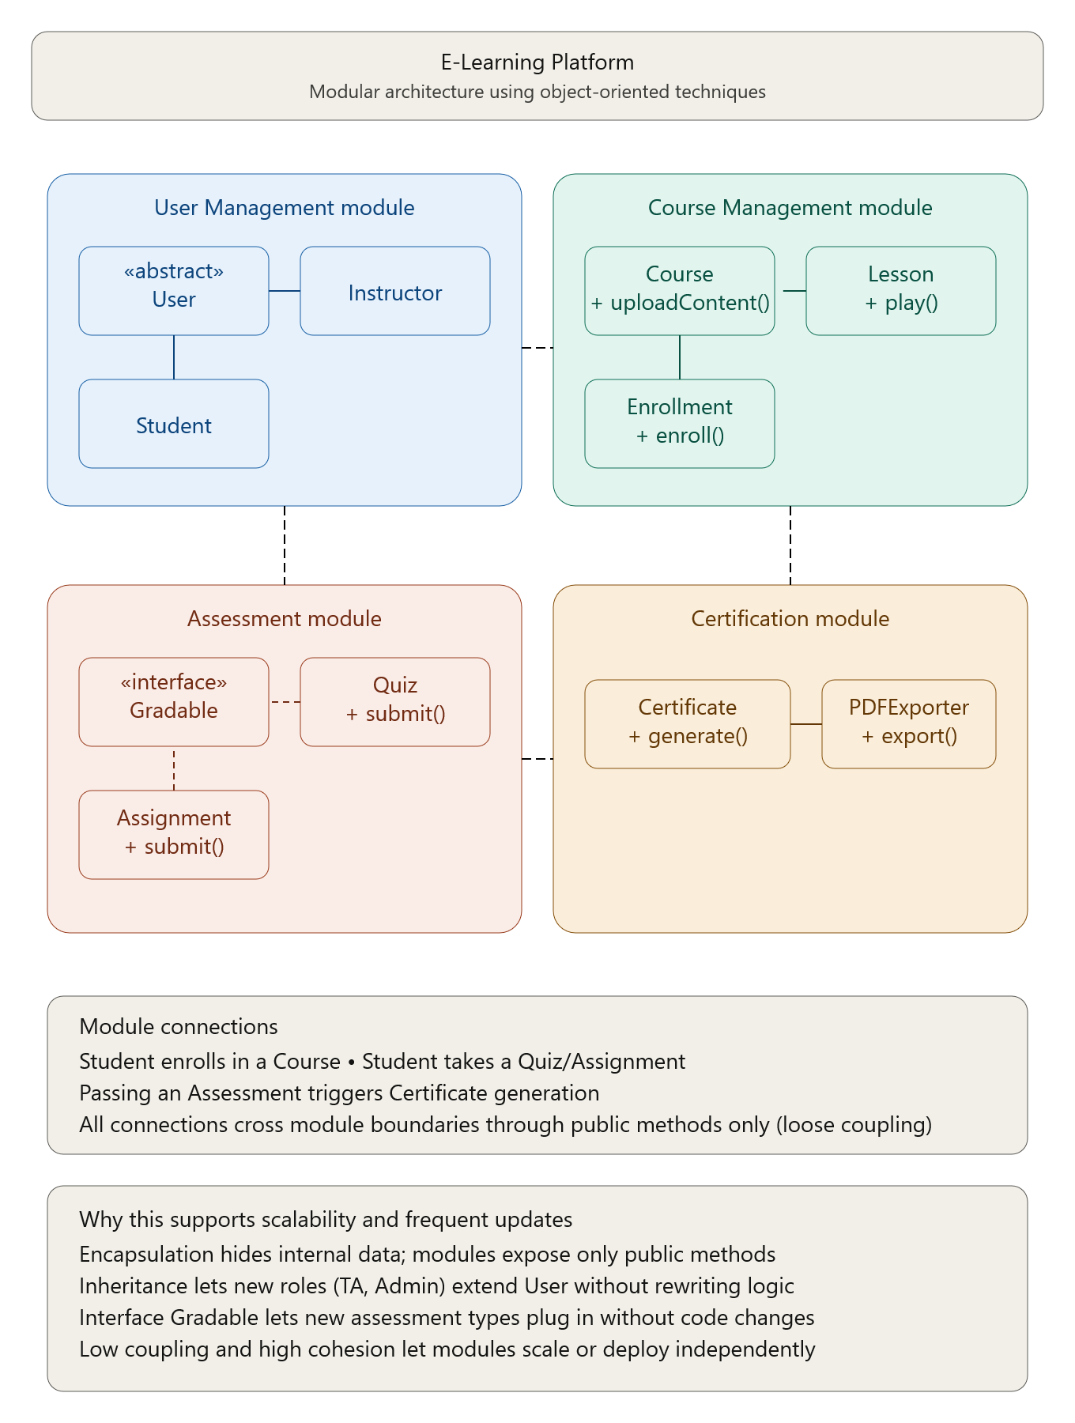

- SDLC evaluation:

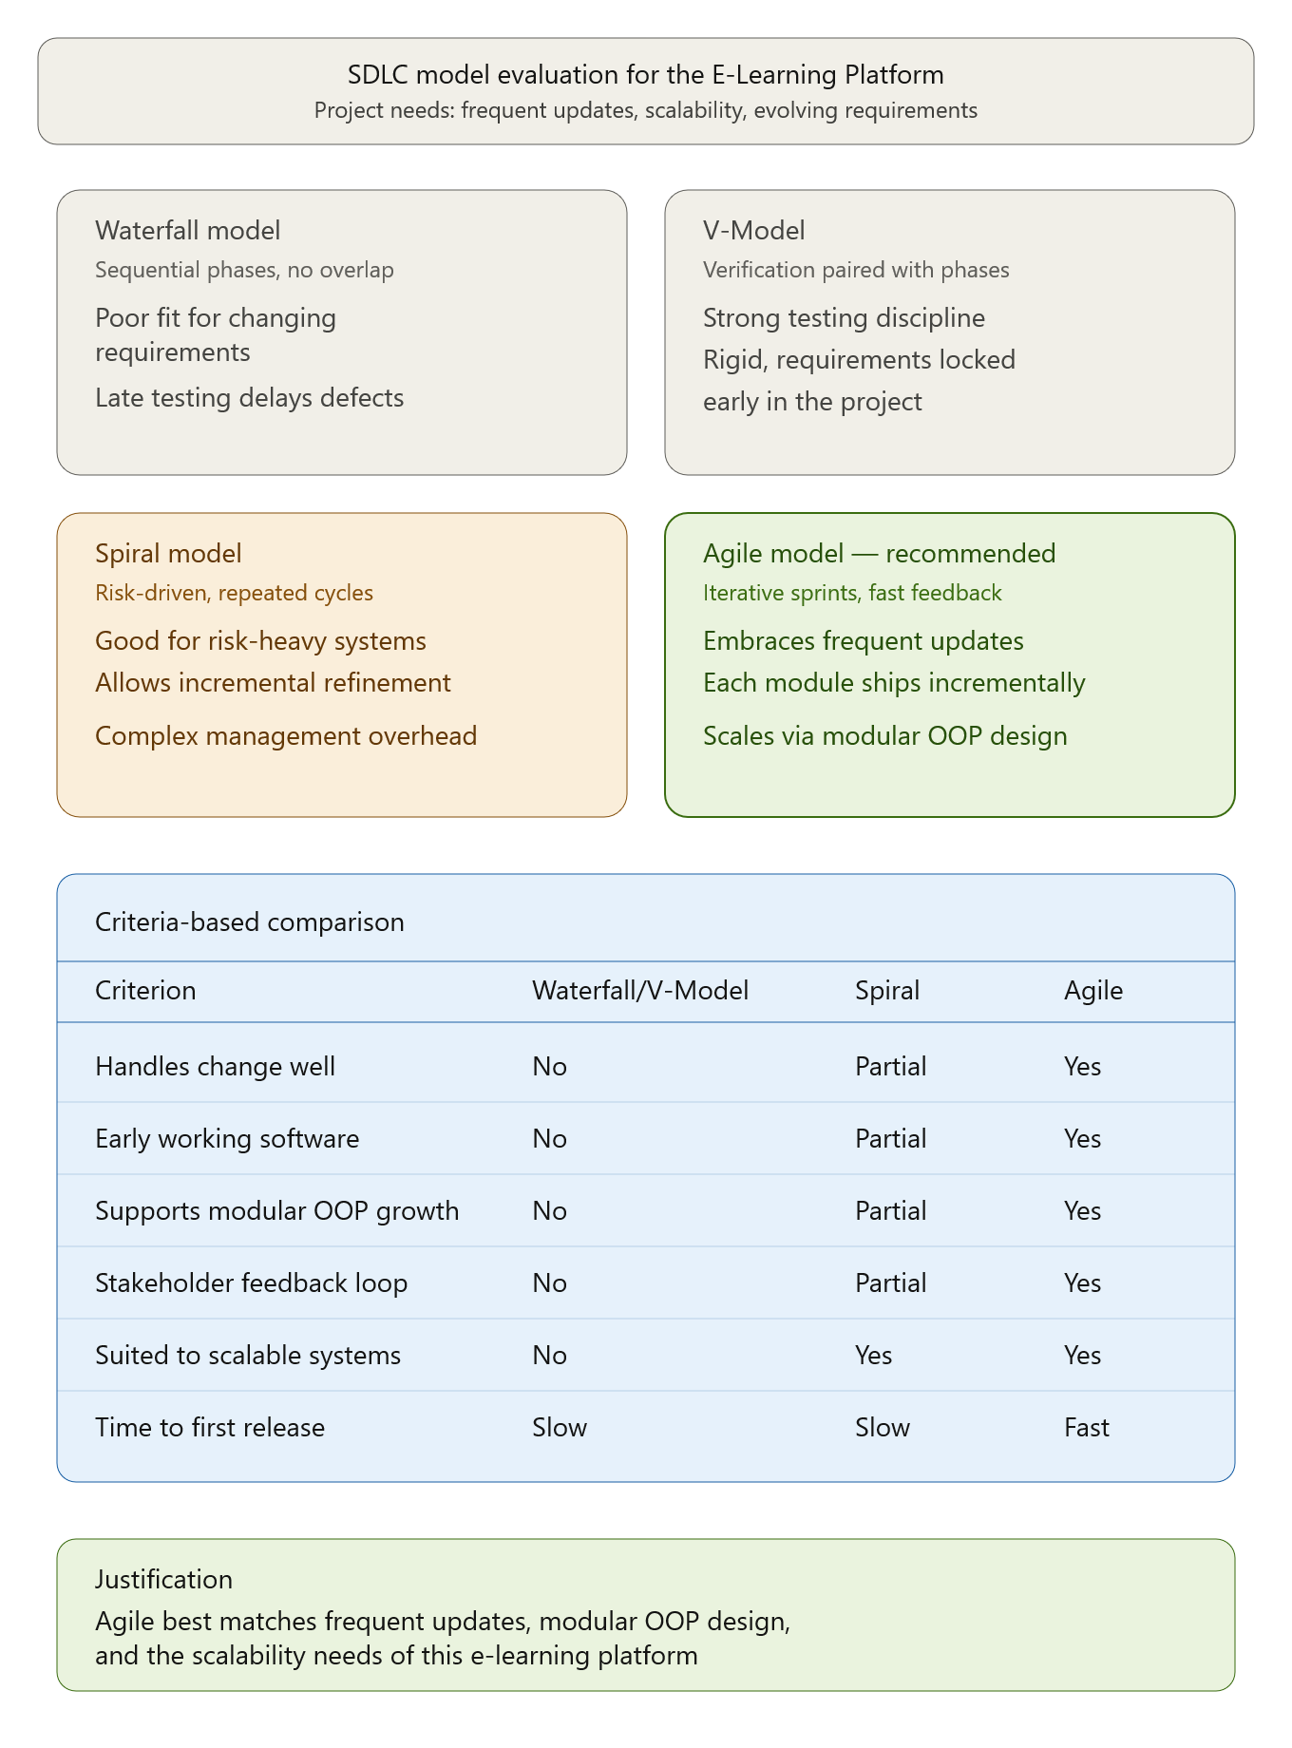

B)
- Object-oriented system development principles

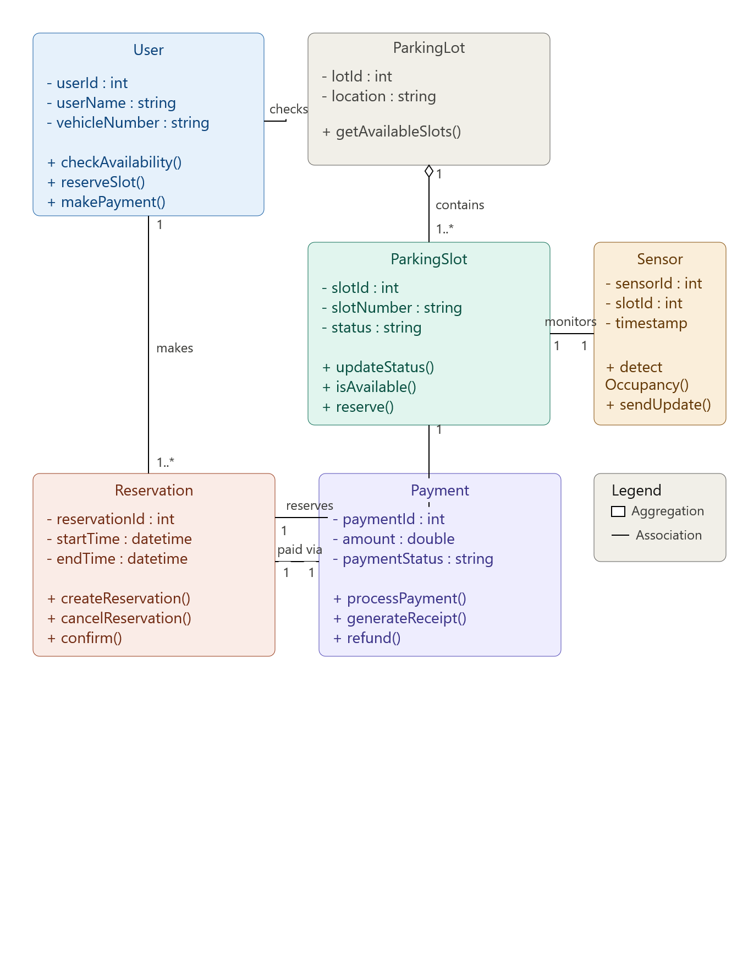

- life cycle model best suited for real-time data and evolving requirements

